Name:________________________ Teacher:_________________


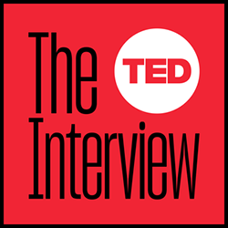







PODCASTS
Booklet

Contents:
- Podcasts
- Rural Australia
- The Conventions of Podcast Script Writing
- Writing your Podcast Script
- Engaging your audience: Pause, Tone, Pitch, Volume

- Podcasts

What is a podcast?
A podcast is like a radio show. However, instead of being broadcast live, a podcast is recorded and then distributed over the internet, so that you can listen to it whenever you please. There are thousands of podcasts available, ranging from general interest entertainment shows to those which focus on specific topics (e.g. computers / music / education).
Definition:
A digital audio file made available on the Internet, typically available as a series, new instalments can be received by subscribers automatically.

How do I listen?
You can usually listen to podcasts directly on the websites of those people who make it. However, you can also "subscribe" to podcasts using software like iTunes and Stitcher. These programs will automatically download the latest shows, and you can then listen to them on your computer and mobile device.


Podcasts you may have listened to or heard of:
- The Claremont Serial Killer
https://thewest.com.au/news/claremont-serial-killings/claremont-the-claremont-serial-killings-podcast-ng-b881118296z

- Coronacast – Norman Swan
https://www.abc.net.au/radio/programs/coronacast/borders-are-coming-down-were-they-based-on-science-or-politics/12920804

- Barrenjoey Road
https://www.abc.net.au/radio/programs/truecrime/barrenjoey-road-ep1/10351016

- Take 5: Tame Impala’s Songs that Would Surprise
https://www.abc.net.au/radio/programs/take-5/tame-impala-take-5/12677194

- Troll Play: Rough play, lovebirds and we’re all going to die
https://www.abc.net.au/radio/programs/troll-play/facebook-bartering-sick-pets/9826082

- Conversations: Dara McAnulty and the Joys of Nature
https://www.abc.net.au/radio/programs/conversations/dara-mcanulty-young-naturalist/12913194

THINK. PAIR. SHARE. What podcasts have you listened to?

What did you enjoy about the podcasts mentioned? What were the subjects?

What elements of the podcasts do you remember: the interviews, conversations, music, sound effects or anything else?

Podcast Characteristics:
- Purpose – persuade, inform or entertain.
- No pre-determined length, format, style, production level (sound effects and music), or anything else.
- Balance - the amount of time a podcast spends exploring each side of an issue or if the opposing side is given the opportunity to have a voice.
- Subjectivity - a good podcast should maintain a neutral tone but often podcasters have an emotional connection to their subject.
- Opinions
- Credibility - credible podcast will use facts sourced from resources that are checked for accuracy.

Podcast Listening Activity
Next, while listening to each of these three short podcast excerpts take notes using the notetaking sheet below. You will need to identify both the episode topic (what is being said or discussed) and the production elements (the various aspects of the podcast that create the listening experience).
- The Claremont Serial Killer https://thewest.com.au/news/claremont-serial-killings/claremont-the-claremont-serial-killings-podcast-ng-b881118296z
- Take 5: Tame Impala’s Songs that Would Surprise https://www.abc.net.au/radio/programs/take-5/tame-impala-take-5/12677194
- Conversations: Dara McAnulty and the Joys of Nature
https://www.abc.net.au/radio/programs/conversations/dara-mcanulty-young-naturalist/12913194
Podcast Excerpt | Topic | Production Elements
The Claremont
Serial Killer

Take 5: Tame Impala’s Songs that Would Surprise

Conversations: Dara McAnulty and the Joys of Nature

Elements and Techniques of Effective Storytelling
There are many different types of podcasts. Some consist largely of conversations between the hosts; others are based on interviews; still others involve mostly storytelling, nonfiction or fiction. Podcasts serve different purposes too: some try to make you laugh; others aim to keep you in suspense; some want to educate or inform. Think about stories your parents, family or friends told have told you — or that you heard on the radio or somewhere else. What are the elements and techniques of great storytelling? How can stories we hear, but can’t see, sometimes be even more powerful than stories dramatized or documented on TV or in film?
- Elements and techniques of great storytelling:
  - Suspense
  - Expression
  - Emotive language
  - Being dramatic
- Can stories we hear be better than dramatized stories on screen?
  - Allow you to use your imagination
  - I believe audio can be more captivating than watching something on a screen
Listen to one or more of these short audio stories and follow along with the transcript (if available. Take notes using the notetaking sheet below.
- “When the Civil War Ended, She Was My Age” from Story Corps
- “Seeking an End to Cycles of Abuse” from Radio Rookies
- “The Coal Miner” from The World According to Sound

Elements and Techniques of Effective Storytelling

Conflict: Conflicts add suspense or tension to stories. They can be internal – for example, someone having a hard time making a decision. Or they can be external, such as an obstacle in the way of someone reaching her or his goal.
Dramatic arc or plot: Many stories have a clear beginning, middle and end. One or many characters are often on a kind of emotional or physical journey, where the end Is usually not the same as the beginning.
Developed characters: These are characters with some kind of backstory, personality or details that make them seem real.
An interesting setting: Many stories take us places we can’t go ourselves. Maybe that’s just inside a home, or maybe it’s behind the scenes of an event.
Reflection: What did the character learn from her or his experience? How did she or he change?
Great sounds: This is audio, after all! Is the character’s voice interesting? What can you tell about them from their voice? Were there other interesting sounds? How did the character make you feel? Interested? Uncomfortable?

Activity: Telling a story

Prompt: “Growing up in Rural Australia”

Using the prompt, think of a story that would be engaging to tell. Use the space below to jot down a few notes about the story, its setting, main events, characters and conflicts.
_______________________________________________________________________________________________________________________________________________________________________________________________________________________________________________________________________________________________________________________________________________________________________________________
___________________________________________________________________________
___________________________________________________________________________
___________________________________________________________________________
Now tell the story to a partner. As you listen to each other, keep track of which elements and
techniques of effective storytelling are being used and provide feedback to one another after

Text 1: When the Civil War ended, she was my age
Conflict (please circle) Internal OR External

Dramatic arc or plot (please circle) Emotional Journey OR Physical Journey
Beginning
Beginning

Middle
Middle

End
End

Developed characters

An interesting setting

Reflection

Great sounds

Text 2: Seeking an End to Cycles of Abuse
Conflict (please circle) Internal OR External

Dramatic arc or plot (please circle) Emotional Journey OR Physical Journey
Beginning
Beginning

Middle
Middle

End
End

Developed characters

An interesting setting

Reflection

Great sounds

Text 3: The Coal Miner
Conflict (please circle) Internal OR External

Dramatic arc or plot (please circle) Emotional Journey OR Physical Journey
Beginning
Beginning

Middle
Middle

End
End

Developed characters

An interesting setting

Reflection

Great sounds

- Rural Australia

Two young Australians share their stories about growing up in regional Australia. Read each extract and answer the questions that follow.

Heywire winner, Taylor Dolling, Kielpa, South Australia
I can't stop this drought, but I wish I could — it's relentless.
But I can stop these little lambs from dying.
My family farm is on the Eyre Peninsula in South Australia.
It's a mixed farm, where we have 600 breeding ewes and grow wheat, barley and oats.
Running the farm keeps Mum and Dad really busy.
My sister and I look after the orphaned lambs, which we call poddies (poddy means fed by hand).
They have become my alarm clock because at 5.00am they're bleating outside my window: "Mum! I'm hungry!"
Oh, I'd love to sleep-in but they need breakfast and it's my responsibility to feed them. I get up and weigh-out the milk powder to make 10 litres of milk.
There's 20 lambs in the orphanage at the moment and I make sure they all get a feed.
Some of these lambs were left by their mums at birth, some of their mums died, or others didn't have enough milk to feed their babies. It's sad, but it's the reality of farm life.
It happens more in a drought when there's less feed for the mums.
I make sure the lambs feel loved and nurtured, but I try not to get too attached because they'll head out into the paddock with the rest of the mob when they get big enough.
There's one though, Spotto, that's fluffy with a big, black spot on his eye.
He doesn't recognise me now he's grown up, but I watch out for him.
A lot of people come home from school to relax, but I jump off the bus and start working to feed the lambs again.
It's hard work but it's rewarding.
I'm their mum and I've kept them alive. And do you know the best bit?
When I get off the bus and see 20 lambs bounding towards me, that's the best feeling ever.

Heywire winner, Jivaughn Coaby, Broome, Western Australia
I am a Yawuru Nyigina boy living in Broome-town.
The relaxed lifestyle up here, full of fishing, footy and hunting, is something I've always enjoyed, but I've always struggled at school.
I failed many of my NAPLAN tests and was often late to class.
I hardly ever handed in my homework and I'm pretty sure some teachers didn't even know what I sounded like because I barely spoke in class.
But I knew I had to step-up out of my comfort zone if I was to achieve my goal of one day going to university.
Out of all my family, only my nanna has been to uni — she's an inspiration to me.
She tells me her story of how she left Broome in the 90s to go to Perth to study nursing.
For six long years she worked hard to reach her Bachelor of Applied Science.
She worked that hard that she won a Vice Chancellor's award for being in the top 1 per cent of all students!
She's an inspiration for me to do better at school.
So I started showing up on time and paying more attention.
I even handed my homework in and interacted with the teachers.
I was blown away the day I received five certificates at a school assembly for best student for English, maths, media, science and geography.
After that, they put me up in higher classes!
In Year Nine I put my hand up to be a student councillor, where I helped with school carnivals and school balls.
In Year 10 I got to go on a leadership camp to Japan.
We took the Year 7 students over and I was part of the leadership team.
I learnt so much on that trip, not just about Japanese culture, but about being a leader.
I have joined an after-school program called Follow The Dream.
It's a space for students to stay back after school to focus on their subjects with some help from the teachers.
Each day I feel I'm getting closer to my dream of going to uni, and I'm on track to complete Year 12 with flying colours.
With lots of passion and hard work, one day there will be two people from my family that will have attended university; Nanna and me!

Questions

Summarise each story in your own words.
Title 1:_______________________________________________________________________________
Summary:
____________________________________________________________________________________________________________________________________________________________________________________________________________________________________________________________________________________________________________________________________________________
Title 2:_______________________________________________________________________________
Summary:
____________________________________________________________________________________________________________________________________________________________________________________________________________________________________________________________________________________________________________________________________________________

Identify the issues each story describes. Have you experienced any of these living in regional Australia? Describe and explain.
____________________________________________________________________________________________________________________________________________________________________________________________________________________________________________________________________________________________________________________________________________________

Below is a list of more issues that relate to living in regional Australia. Select an issue that you have personally experienced and answer the questions that follow.

Lack of job opportunities, drought, the impact of live export on farm owners, working on a farm at a young age, less choice in education, smaller communities, travel time, social media, limited choice of sporting activities.
- Issue selected
- Description of the issue
- Your personal experiences with the issue
- How you overcame or are trying to overcome the issue.

Beyond Imagination

Not all podcasts are imaginative or interpretive texts, like the ones explored above in this section. For some, their main purpose is to inform listeners and so the way they select, omit and/or emphasise information is the key to their construction. Bias is created when both sides of an issue are not explored equally or when one version of the truth is favoured over another.

The following section of this handout, The Conventions of Podcast Script Writing and the templates it contains, show you different ways to structure an informative podcast. These are not the only way podcasts can be organised but they allow you to communicate and present your ideas in a logical way. Once you have identified the facts, opinions, supporting evidence and bias (or the avoidance of bias) you wish to use, the next step is to create your own podcast!

3. The Conventions of Podcast Script Writing
How to write a podcast script is one of the biggest questions new podcasters ask when recording their first episode. The best podcast episodes may sound like casual, free-flowing conversations, but that’s due to the hours of preparation and planning the hosts do before hitting the record button.

Ahead, we offer some best practices to get your started, whether you plan to prepare a word-for-word script or want to leave room for adlibbing. We’ll give you a high level view of what a podcast script looks like, go over some tips to help you write your first script, and discuss the three podcast formats that require scripting for cohesive episodes.

A. Podcast Script Outline Templates
When you write a podcast script, it helps to start with a bird’s eye view of your show. This outline will create a guide that keeps you on track and ensures you hit all the right points. It will also help you prepare transitions and get everything in within the allotted time. Here’s a sample of a podcast script template. Notice how it includes all of the important segments listed above. In the case of an interview podcast, replace each topic with a question for your guest.
- Sponsor message
- Introduction
- Musical jingle/sound effects
- Longer explanation of what’s in store
- Topic 1
  - Main point
  - Supporting point
  - Supporting data
  - Supporting quote
- Segue
- Topic 2
  - Main point
  - Supporting point
  - Supporting data
  - Supporting quote
- Sponsor message
- Topic 3
  - Main point
  - Supporting point
  - Supporting data
  - Supporting quote
- Segue
- Outro
- Call to action
- Sponsor message
- Musical jingle/sound effects
Obviously your podcast script doesn’t have to mirror that outline. Customize it to fit the needs of your show and your preferences.

B. Podcast Script Tips for Beginners
We recommend all newbies prepare some kind of podcast script before they hit record. Talking intelligently, smoothly, and clearly is challenging without practice. During the recording, you can focus on your mechanics, like enunciating, removing filler words, and controlling your tone and volume. Over time, you’ll be able to reduce your podcast script to a simple outline with notes.
Here are a few tips that will help you craft an engaging podcast script.

Keep it conversational
The biggest challenge of writing a podcast script is keeping it conversational. If you aren’t careful, reading a podcast script can lead to a flat, monotone delivery.
A lot of podcasters find it useful to speak their script (like a rehearsal for their recording) with a speech-to-text tool open to dictate their words. This creates a natural pattern and puts your words on a page so you can read them during your recording. Just make sure to give it an edit to smooth out rough patches and include all your information. Google Docs has a free tool that comes in handy here. You can even use this as your podcast transcript.

Use delivery notes
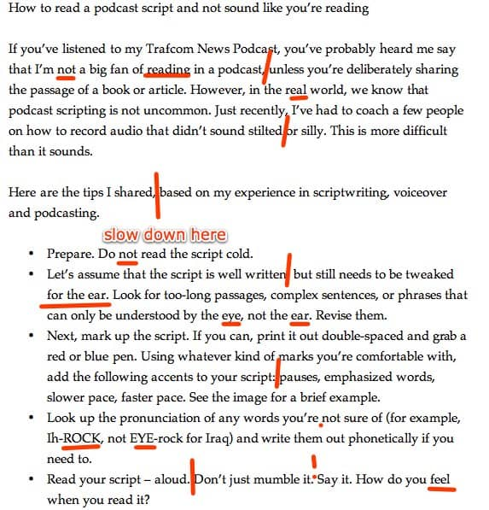
Another trick every good podcast script includes are delivery notes. These are notes within your script that indicate pauses, emphasis, laughs, sighs, and other dramatic effects. These elements breathe life into your podcast script so it feels natural. Make sure to read your podcast script aloud with your delivery notes so they sound genuine.

Allow for some riffing
Just because you write a podcast script before your recording doesn’t mean you are bound to it. It’s quite alright to go off script during your recording if you think of something important or valuable on the spot. If you decide you don’t like it, you can always edit it out later.
That said, be mindful about going off on irrelevant tangents. If you add a bunch of fluff content to your recording, you’re just a waste of time in front of the microphone and you’re editing software later.

Describe the scene
Podcasting is an audio medium, which means our audience doesn’t have any visual cues. If you refer to something, like an image, person, or video, make sure to describe it well so your listeners can picture it in their mind. Your descriptions should be detailed and vibrant.
It sounds easy, but this is a hard skill to master. You may find it is odd to speak to people who aren’t in the room who can’t see what you see. It may help to think of recording a podcast like talking to someone on the phone.
This doesn’t mean you need to give a detailed description of everything you say, but you’ll want to be aware of any concepts, images, or topics that need extra description for your listeners who are effectively blind.

Maintain a reasonable pace
The best podcast episodes maintain a consistent space that keeps listeners engaged. A good pace is not too fast and not too slow. There shouldn’t be any long, unexplained pauses. And there shouldn’t be any moments where you talk too fast to be understood.
Use segments and transitions to keep your podcast script organized and help listeners understand where they are in your episode. For instance, you might divide your episode into chapters with their own titles, or turn your lessons into numbered steps or tips.
Write transition phrases into your podcast script to move between segments. For example, you might say, “Now that you understand the importance of user data, let’s talk about the tools you need to collect it.”

Be yourself
You are a unique person with your own personality. It’s much easier and more natural to be yourself than to try to be someone else, even if that someone else is a successful podcast. While it’s useful to take lessons from the pros, don’t try to mimic them. Write a podcast script that serves your needs and shows off your personality.
C. Basic Podcast Script Segments with Templates
While every podcast script is different depending on which type of show you host, you’ll want to prepare some standard segments ahead of time to make sure you hit all of your talking points. When it’s time for your prepared content, simply read from your prepared segment, then dive back into your episode’s unique podcast script.

Show introduction
A show’s introduction has three key qualities: It’s short, welcomes listeners to the episode, and includes a brief pitch about the podcast. Generally, you’ll use the same script for each episode to consistently welcome listeners to your latest episode. The easiest intro to script follows this basic setup:
“Welcome to [podcast name], the show that [brief podcast pitch or tagline]. I’m [host name] and today we’re talking about [episode topic] with [guest name]. We also have a surprise guest for you at the end of the show, so make sure you listen all the way through.”

Guest introductions
If you interview guests on your podcast, you don’t want to fumble their name or credentials as they’re introduced to the show. Writing out a basic introduction script will ensure that you get it right the first time. This is also a great opportunity to provide context around why your listeners should care about your guest’s expertise. The introduction can be as simple as:
“Now it’s time to welcome [guest name] to [podcast name]. She/he/they are here to [purpose of guest: provide expertise, answer questions, tell their story, etc.]. Hi, [guest first name], thanks for joining us.”

Sponsor ad messages
The scripts for your sponsor’s messaging will depend on how much control the brand wants over their ad placements. A sponsor may provide a word-for-word script you need to follow while others will give talking points where you can add in conversational elements that are unique to your show. In either scenario, you’ll want to chart out exactly what to say so your ads sound natural, your listeners buy their products, and your sponsors keep coming back.
“Today’s episode is brought to you by [sponsor name]. [Sponsor name] is [launch into the benefits of the sponsor’s product or service and why the listener should buy it].
Some sponsors will supply you with a pre-written segment that they expect you to read on your show. These save you the trouble of writing your own segment, but they may feel cold and unengaging. Work with your sponsor to come up with a message that’s right for your audience.

Show outro
Your outro is your opportunity to thank your guests for participating, recap what you discussed (and the value you gave your listeners), and thank your audience for their time, and announce upcoming episodes, events, or promotions.
“Make sure to join our Facebook group [name] if you haven’t already where we break down this episode throughout the week. Get your tickets to our live show in [place] at our website [url] before they sell out.”

Calls to Action (CTAs)
Your calls-to-action are a chance to ask for more listener support, from subscribing to the show on Apple Podcasts or writing a review. These are important for increasing podcast downloads. The best CTAs sound authentic and emphasize how easy it is to do the action you’re asking of your audience. Remember, your CTA priorities will shift over time as you start selling merchandise or offer premium subscriptions so you’ll end up writing a few different scripts to fit each need.

Here’s a good place to start:
“Thanks for listening to [podcast name]. Before we go, show some love for your favorite podcast by leaving us a review on Apple Podcasts. Then stay tuned for next week where we [next episode’s topic].”

D. Types of Podcast Scripts with Templates
The type of show you host is a big factor in whether you decide to write a podcast script. There are generally three types of podcast formats that are best served with a script.

1. Solo show podcasts
If you host a podcast by yourself, it helps to prepare at least a basic outline before you start recording. You may find it difficult to come up with things to say for 30 or 45 minutes if you don’t plan ahead. But many solo shows write a complete word-for-word script of each episode. Once the script is finished, recording and editing are quick and painless. If you decide to write only notes for your podcast script, organize them in a logical order that leads through your content. Start with a few section headers that include supporting data points and relevant anecdotes. Here’s a sample of an outline from GothamCast.
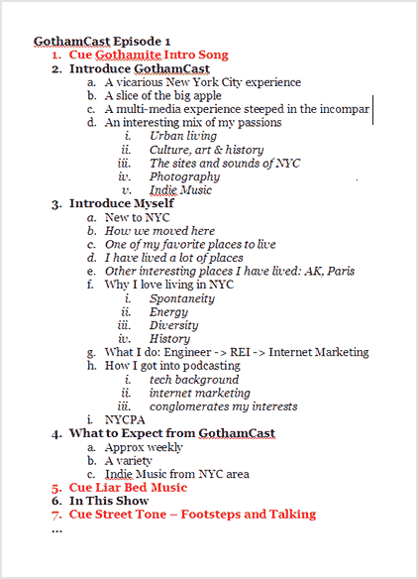
Section headers represent the important topics or themes of your episode, helping you stay on track to avoid forgetting important points. Having this general outline also helps you speak in an active, conversational tone that listeners find engaging. As you gain experience recording from a basic outline, you’ll find it creates some of the most natural sounding and authentic podcast episodes.
One of the biggest advantages of hosting a solo show is you can do a lot of post-production that other podcast formats can’t. If you aren’t happy with the way you said something, you can simply say it again and cut out the mistake later, repeating this process until you’re satisfied.

2. Interview show podcast scripts
Interview-style podcast episodes generally require more podcast script preparation compared to other formats for both you and the interviewee. As the host, it’s important to know exactly what you’ll ask your guest for two main reasons. Detailing a list of questions and main talking points will stimulate conversation, helping you avoid running out of things to say. If you cut the session short because you’re unprepared, your guest may not arrange another time to record. Not only does this leave you looking unprofessional, but you’ll also end up with a partial episode.
Second, your guest likely has less podcast experience than you, so they’re not as comfortable thinking on their feet. Providing a list of questions and comments before the show allows them to prepare the thoughts and anecdotes they want to share during the recording. Essentially, the more comfortable the guest, the more conversational the interview so you create an amazing episode.
Create a list of questions and topics that you hope to address on your show. Send them to your guest a few days before the recording so they have some time to prepare their thoughts.

3. Co-Host show podcast script
When you work with a co-host, it’s best to use a hybrid approach. You’ll want to script some things, but leave other areas of your episode open for organic conversation.
Some organization beforehand will help you avoid some classic co-host mistakes, such as…
- Interrupting one another. (“This is important and I want to mention it before you move on.”)
- Making the same argument your co-host made a moment ago.
- Talking so long people forget your co-host is on the show.
- Transitioning abruptly from one point to another.
Map out your episode with a basic outline (like you would for a solo show) and add supporting points, data, and anecdotes under each heading. Then tag each line item with someone’s name so you distribute the talking smoothly. You’ll want to script and note who will take care of the basic podcast segments of the episode too, like your show’s introduction and CTAs.
Finally, add scripted transitions to your outlines. Questions are the easiest way to do this, sort of like you’re interviewing each other. Here’s an example:
Jim: “…and that’s when the judge sends the jury to deliberate. How long would you say deliberation usually takes in a case like this?”
Mike: “It’s tough to say, but I would expect at least three hours. First, the court has to re-explain the charges…”
Notice how this script with a podcast script written for co-hosts leave space for each person to enter smoothly, and how each is given enough speaking time to make a point without crowding out the other person.
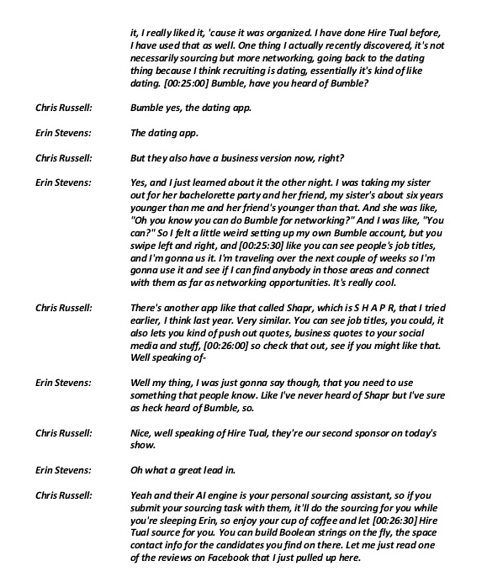
Co-hosted podcast script template example
With a co-host, it’s important to remember to record each person on different tracks. This way you can edit your voices independently later on, saving you a few headaches and a lot of editing time.

Preparation Is Key
Preparation is a critical part of producing high quality podcast episodes. Writing a podcast script is a key way to ensure your audio is clear, tight, and valuable for your listeners. You don’t have to write out every word you intend to say, but it’s important to have notes for each episode to keep you on track, especially if you’re new to podcasting.
Do you create a podcast script for each episode? How detailed do you make it? Let us know in the comment.

Definitions:
Script | The written text of a play, film, or broadcast.
Transcript | A written or printed version of material originally presented in another medium.

What are the conventions of script writing?

• Use a clear font

• Left alignment

• Write stage directions in italics

• Leave 1.5-2cm margins on each side

• Use double spacing between characters

• Use single space for characters’ speech

• Write CHARACTER’S names in capital letters

• Separate character names from dialogue

• E.g. CHARACTER Dialogue.

Podcast Script Writing Activity

Your teacher will select a podcast. Listen to the podcast and complete the activities that follow.

Activity One

Podcasts use a variety of pace, pitch, pause and tone to engage their audience. How does the podcast you have listened to utilise these features? Describe each and decide whether it was effective or not.
 | Description | Effective
Pace | The speed at which someone speaks, e.g. the speed of response in an argument. | - Speed is dependent on content, usually good to talk slowly and clearly without sounding boring
Pitch | Speaking in a high, low or natural voice. | - Natural voice is most effective
Pause | e.g. a dramatic pause at a crucial moment could merit a comment. | Use pauses for effect depending on content – too many pauses will bore the listener. No um’s and ah’s!
Tone | This suggests your mood and your intention towards the listener, e.g. happy or sad. | Engaging tone, content dependent but don’t sound dull/depressed, not engaging.
Activity Two

Using your knowledge of script conventions, use the space provided on the next page to write a script for the first three minutes of the podcast that you have listened to.

Before beginning your script, make sure to write the name of the podcast, its speakers and a brief description of its content below.

Podcast name | Regional Voices – Society and Culture  Indigenous Education
Speakers names  If you do not have the names of the speakers label them Speaker A, Speaker B etc. | Corey Grech – Teacher  Interviewer
Brief description of podcast | Wrapping up our month of celebrating indigenous culture and achievements is our interview with Corey Grech.  Corey is an educator who grew up in Coonabarabran NSW and now works on the Central Coast of NSW. He focuses his education on keeping the indigenous culture alive and empowering kids to become as resilient and self-reliant as they can.

Script practice:
(introductory music)

PRESENTER: Regional Voices – The new voice of regional Australia.

(background music fades into interview)
INTERVIEWER: Welcome to Regional Voices. I’m Sue Hardman. This
week we talk to Corey Grech. Welcome, Corey.
COREY: Hi, how are you?

INTERVIEWER: I’m well, thank you. Have you always been
interested in working with children?

COREY: Yeah, I always wanted a big family. I grew up…

- Writing your Podcast Script

You are now ready to write your podcast script! Follow the steps below.
- Read through your task sheet and identify what is expected of you.
- Select your group members.
- Begin planning your podcast.

4a. Brainstorm

Environmental Social

POSSIBLE ISSUES

4b. Select Issue: The issue I have chosen for my podcast is: ________________________

4c. Possible research questions to ask about the issue

4d. Facts that address each question

4e. Opinions that address each question
Definition: OPINION
An opinion is a view or judgement formed about something, not necessarily based on fact or knowledge.
- the beliefs or views of a group or majority of people
- an estimation of the quality or worth of someone or something
It is also a statement of advice by an expert on a professional matter. Other words for opinions are: ideas, understandings, thoughts, notions, opinions, views or beliefs.

4f. Other supporting evidence to that addresses each question

4g. Possible perspective/s to develop
Definition: PERSPECTIVE
A position from which things may be viewed or considered. People may have different perspectives on events or issues due to (for example) their age, gender, social position and beliefs and values (or their context). A perspective is more than an opinion; it is a viewpoint informed by one or more contexts Texts through an embedded ideology can also present a particular perspective or be read from an ideological perspective.

4h. Distribute roles to be undertaken by each group member.

Group Roles

4i. Begin writing your script.

5. Engaging Your Audience: Pitch, Pace, Pause and Tone

Describing Voice
The voice is a powerful tool. When you describe vocal work, consider elements such as pace, pitch, pause, tone and volume. You should always use a suitable language register to engage your audience.

There are a number of different vocal elements you should consider when deciding how to effectively engage your audience:
- Pitch – speaking in a high, low or natural voice.
- Pace – the speed at which someone speaks, e.g. the speed of response in an argument.
- Pause – a dramatic pause at a crucial moment could merit a comment.
- Tone – this suggests your mood and your intention towards the listener, e.g. happy or sad.
- Volume – you might be commenting on audibility but you’re more likely to be discussing the effect of a loud, powerful voice or a quiet, nervous or sad voice.
- Emphasis – the pressure on individual words that makes them stand out. Emphasis or stress for a particular effect is significant and can change the meaning of a sentence as well as the feeling behind it.
- Intonation – the rise and fall of the voice. There’s a clear movement up at the end of a sentence when we ask questions for example. Intonation also helps us to say what we mean.

Intonation exercise
Read the following:
Hello, how are you? I heard you’d been ill but I see you’re better now. I’m glad. When are you going to be back at work?
The first time you read it emphasise the words that are outlined in bold only. You should find the words in bold are very concerned and sympathetic.

Now say the same line again but this time say the words that are in bold sarcastically. It will sound as if you doubt whether the listener really has been ill. Intonation can determine how audiences perceive you.

You are now ready to begin practicing your script with your group members. Make sure to pay attention to each other’s pace, pause, volume, pitch and tone. Provide constructive feedback to one another while you are practicing. Remember, your goal as a group is to engage your audience with your content.

